**Source Code**

from flask import Flask, render_template, request

import datetime

import requests

app = Flask(_name_)

@app.route('/', methods=['GET', 'POST'])

def weather():

if request.method == 'POST':

city = request.form['city']

access_key = 'b9b92db6cd0c77b28add23aeb78ca04e'

url =

f"https://api.openweathermap.org/data/2.5/weather?q={city}&appid={access_key}"

response = requests.get(url)

if response.status_code == 200:

data = response.json()

temperature = round(data['main']['temp'] - 273.15, 2)

temp_min = round(data['main']['temp_min'] - 273.15, 2)

temp_max = round(data['main']['temp_max'] - 273.15, 2)

humidity = data['main']['humidity']

description = data['weather'][0]['description'].capitalize()

country_code = data['sys']['country']

lat = data['coord']['lat']

lon = data['coord']['lon']

feels_like = round(data['main']['feels_like'] - 273.15, 2)

pressure = data['main']['pressure']

sunrise = data['sys']['sunrise']

sunset = data['sys']['sunset']

country = data['sys']['country']

return render_template('weather.html', temperature=temperature,

humidity=humidity, description=description, city=city,

country_code=country_code,lat=lat,

lon=lon,temp_min=temp_min, temp_max=temp_max,

feels_like=feels_like, pressure=pressure, sunrise=sunrise, sunset=

sunset, country=country)

else:

return render_template('home.html', error_message="City not found, please try

again.")

else:

return render_template('home.html')

if _name_ == '_main_':

app.run(debug=True)

Home html :

<!doctype html>

<html lang="en">

<style type='text/css'> body{

background-image:

url('https://i.pinimg.com/originals/0e/f3/bb/0ef3bb66d9216fffcea9022628f7bb26.gif'); background-size: cover;

font-family: sans-serif; margin-top: 40px; height: 100vh; padding:0;

margin:0;

}

.regform {

background-color: rgb(0, 0, 0, 0.8); margin: 0px 20px 0px 20px;

color: #FFFFFF;

padding: 10px 0px 10px 0px; text-align: center;

border-radius: 15px 15px 0px 0px;

}

.main-form {

margin: 0px20px 0px 20px; background-color: rgb(0, 0, 0, 0.7); padding-top: 20px;

padding-left: 50px;

51

padding-right: 50px; padding-bottom: 20px;

color: #FFFFFF;

}

.details{

font-weight: bold; font-size: 17px;

}

</style>

<head>

<!-- Required meta tags -->

<meta charset="utf-8">

<meta name="viewport" content="width=device-width, initial-scale=1">

<!-- Bootstrap CSS -->

<link href="https://cdn.jsdelivr.net/npm/bootstrap@5.0.0- beta3/dist/css/bootstrap.min.css" rel="stylesheet"

integrity="sha384- eOJMYsd53ii+scO/bJGFsiCZc+5NDVN2yr8+0RDqr0Ql0h+rP48ckxlpbzKgwra6" crossorigin="anonymous">

<title>Marine Weather Forecast</title>

</head>

<body>

<div class='regform mt-3'>

<h1>Marine Weather Forecast</h1>

</div>

<formaction='/' class='main-form' method="POST">

<div class='text-center'>

<input type="text" id="city'" name='city'' placeholder="Enter the Location" style="font-size:20px;margin-bottom:10px;width: 700px;">

<button type='submit' class='btn btn-outline-success'

style="margin-top:10px;margin-bottom:10px;width: 700px;"> What's the

Weather

</button>

</div>

</form>

{% if error %}

<div class='text-center'style="margin: 0px 20px 0px 20px;background-color: rgb(0, 0, 0, 0.7);color: #FFFFFF; padding-bottom: 20px;">

<h2>{{ error }}</h2>

</div>

{% endif %}

{% if name %}

<div style="margin: 0px 20px 0px 20px;background-color: rgb(0, 0, 0, 0.7);color: #FFFFFF; padding-bottom: 20px;">

<div class="row text-center">

<h1>Current Temperature in {{ city }}</h1>

</div>

<div class="row text-center" style="margin-top: 10px;">

<h2>{{ temp_c }}°C / {{ temp_f }}°F <img src='{{ condition_icon }}'></h2>

</div>

<div class="row text-center" style="margin-top: 20px;">

<div class="details col">

<p>country: {{ country }}</p>

</div>

<div class="details col">

<p>Latitude: {{ lat }}</p>

</div>

<div class="details col">

<p>Longitude: {{ lon }}</p>

</div>

</div>

<div class="row text-center" style="margin-top: 20px;">

<div class="details col">

<p>Description: {{ description }}</p>

</div>

<div class="details col">

<p>Feels Like: {{ feels_like }}°C</p>

</div>

<div class="details col">

<p>Wind Speed: {{ wind_speed }} km/h</p>

</div>

<div class="details col">

<p>pressure: {{ pressure }}</p>

</div>

<div class="details col">

<p>Humidity: {{ humidity }}%</p>

</div>

</div>

<div class="row text-center" style="margin-top: 20px;">

<div class="details col">

<p>Minimum Temperature: {{ temp_min }}°C</p>

</div>

<div class="details col">

<p>Maximum Temperature: {{ temp_max }}°C</p>

</div>

<div class="details col">

<p>Sunrise: {{ sunrise }}</p>

</div>

<div class="details col">

<p>sunset: {{ sunset }}</p>

</div>

</div>

</div>

{% endif %}

</body>

</html>

Index html :

<!DOCTYPE html>

<html>

<head>

<title>Weather App</title>

<link rel="stylesheet" type="text/css" href="{{ url_for('static', filename='style.css') }}">

<style>

body { margin: 0;

padding: 0;

background-image: url("../static/background.jpg"); background-size: cover;

}

.container { display: flex;

flex-direction: column;

justify-content: center; align-items: center; height: 100vh;

}

.search-container { display: flex;

justify-content: center; align-items: center; margin-bottom: 2rem;

}

.search-container input[type="text"] { padding: 0.5rem;

border-radius: 4px 0 0 4px; border: none;

width: 20

}

</style>

</head>

<body>

<div class="container">

<div class="search-container">

<form method="POST" action="/">

<input type="text" placeholder="Enter city name" name="city">

<button type="submit">Search</button>

</form>

</div>

{% if error_message %}

<div class="error-message">{{ error_message }}</div>

{% endif %}

<div class="weather-container">

<div class="weather-details">

{% if temperature %}

<div class="temperature">{{ temperature }}°C</div>

{% endif %}

{% if humidity %}

<div class="humidity">Humidity: {{ humidity }}%</div>

{% endif %}

{% if description %}

<div class="description">{{ description }}</div>

{% endif %}

{% if feels_like %}

<div class="feels_like">{{ feels_like }}°C</div>

{% endif %}

{% if Sunrise %}

<div class="Sunrise">{{ Sunrise }}°C</div>

{% endif %}

{% if Sunset %}

<div class="Sunset">{{ Sunset }}°C</div>

{% endif %}

</div>

{% if city %}

<div class="city">{{ city }}{% if country_code %}, {{ country_code }}{%

endif %}</div>

{% endif %}

</div>

</div>

</body>

</html>

Weather.html :

<!DOCTYPE html>

<html>

<head>

<title>Weather App</title>

<link rel="stylesheet" type="text/css" href="{{ url_for('static',

filename='style.css') }}">

<style>

body {

margin: 0;

padding: 0;

background-image: url("../static/background.jpg");

background-size: cover;

}

.container {

display: flex;

flex-direction: column;

justify-content: center;

align-items: center;

height: 100vh;

}

.search-container {

display: flex;

justify-content: center;

align-items: center;

margin-bottom: 2rem;

}

.search-container input[type="text"] {

padding: 0.5rem;

border-radius: 4px 0 0 4px;

border: none;

width: 20

}

</style>

</head>

<body>

<div class="container">

<div class="search-container">

<form method="POST" action="/">

<input type="text" placeholder="Enter city name" name="city">

<button type="submit">Search</button>

</form>

</div>

{% if error_message %}

<div class="error-message">{{ error_message }}</div>

{% endif %}

<div class="weather-container">

<div class="weather-container">

<div class="weather-details">

{% if temperature %}

<div class="temperature">{{ temperature }}°C</div>

{% endif %}

{% if humidity %}

<div class="humidity">Humidity: {{ humidity }}%</div>

{% endif %}

{% if description %}

<div class="description">{{ description }}</div>

{% endif %}

{% if feels_like %}

<div class="feels_like">{{ feels_like }}°C</div>

{% endif %}

{% if Sunrise %}

<div class="Sunrise">{{ Sunrise }}°C</div>

{% endif %}

{% if Sunset %}

<div class="Sunset">{{ Sunset }}°C</div>

{% endif %}

</div>

{% if city %}

<div class="city">{{ city }}{% if country_code %}, {{ country_code }}{%

endif %}</div>

{% endif %}

</div>

</div>

</body>

</html>

Output screenshots

STEP 1 : Type cmd in directory location

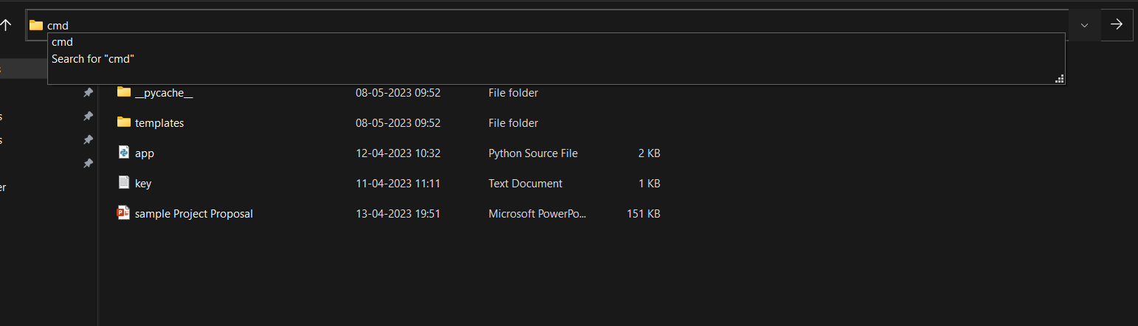

STEP 2 : Now Type code . in cmd (Command Prompt)

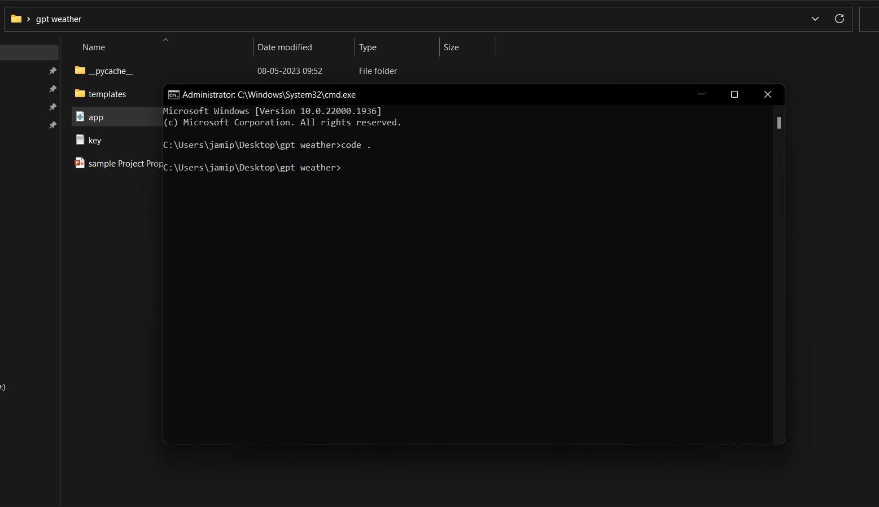

STEP 3 : Open New Terminal.

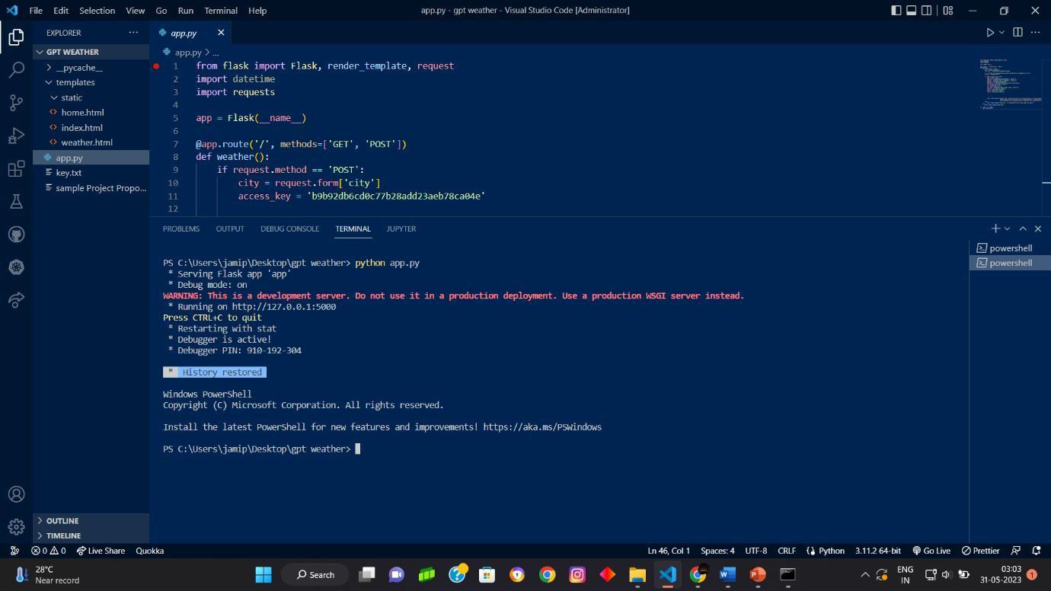

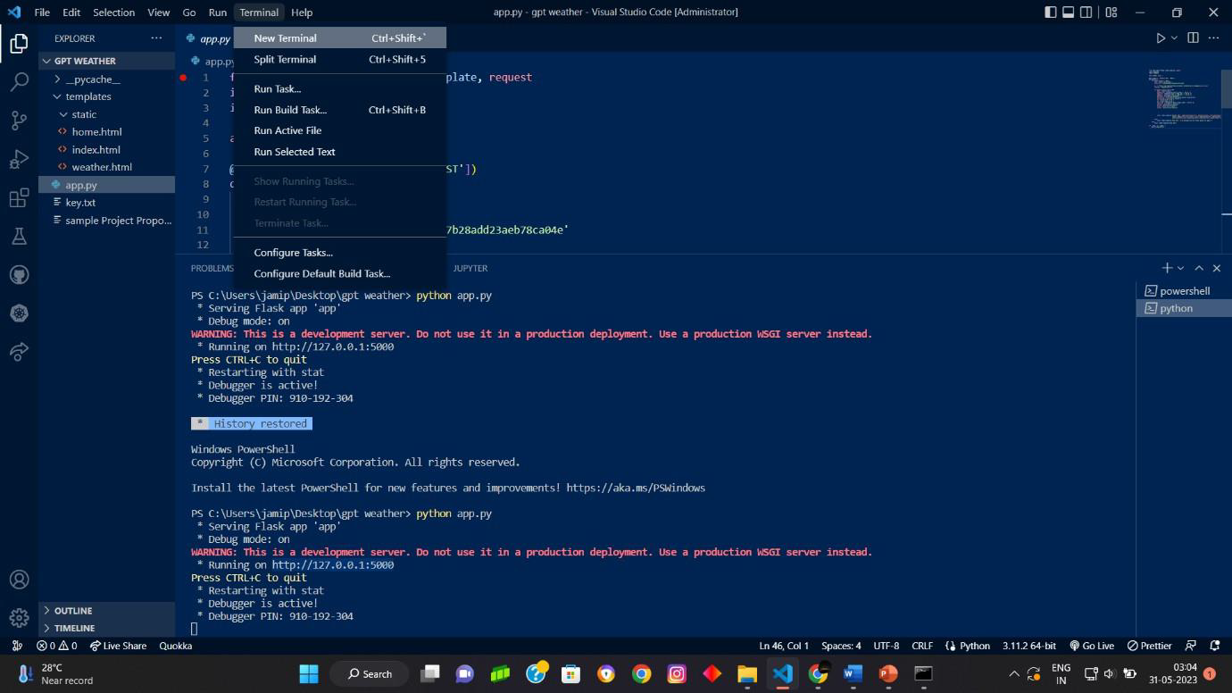

STEP 4 : Click and open the generated URL.

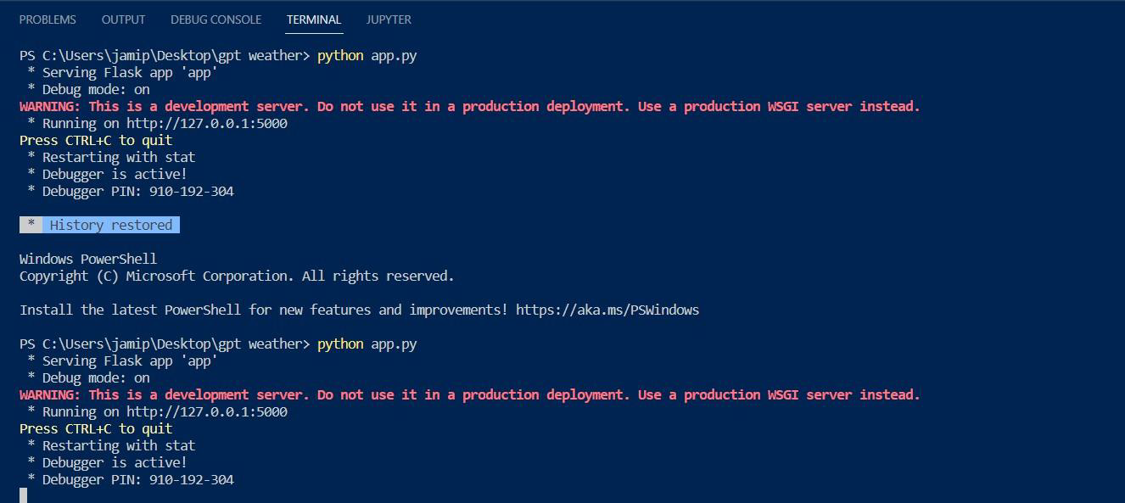

STEP 5 : Enter the location Manually.

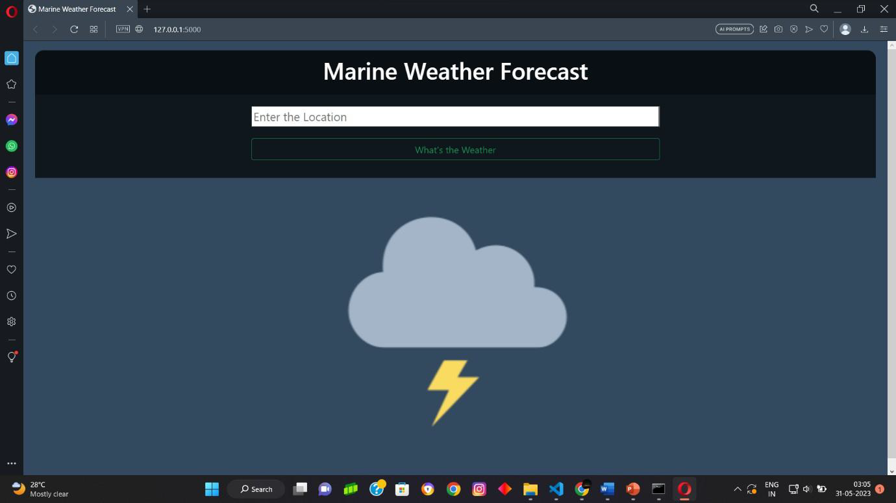

STEP 6 : Click on “What’s the Weather” Button and here is the weather details.



